## DATA ACQUISITION EXERCISE

## “ACQUIRE A REMOVABLE MEDIA USING FTK IMAGER”

## SUBMITTED BY ADENIKE OLUWABUSOLA ONI

***FTK Imager Software***

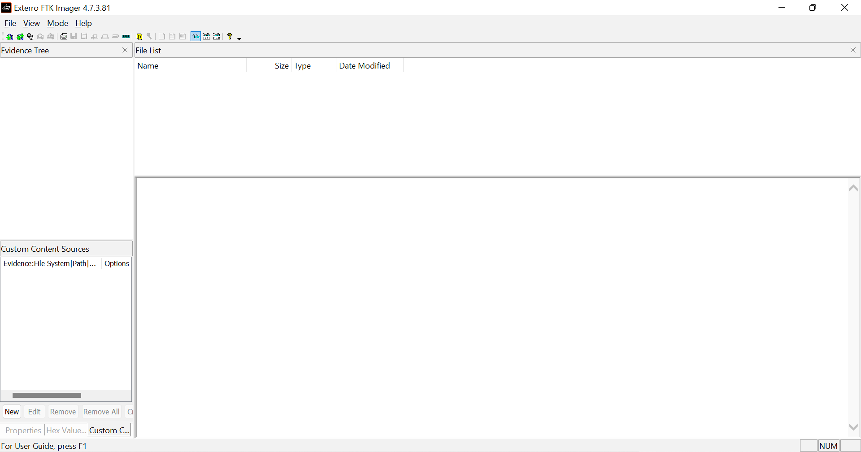

Step 1:- Select the evidence source type

File - Add Evidence Item - Physical drive - Next

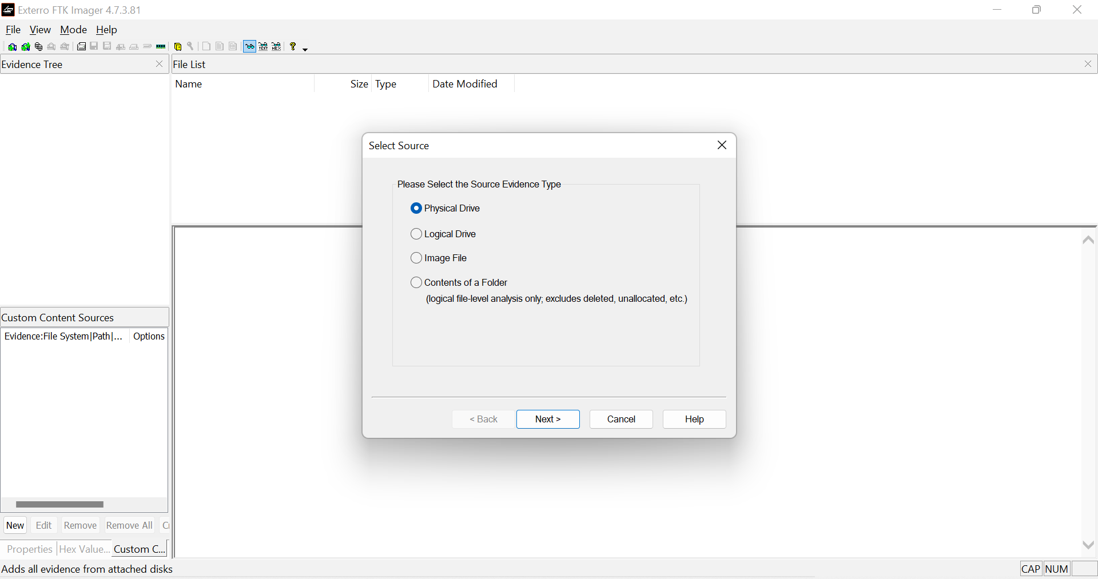

Step 2:- Source drive selection.

Select the attached drive in the drop-down menu - Finish

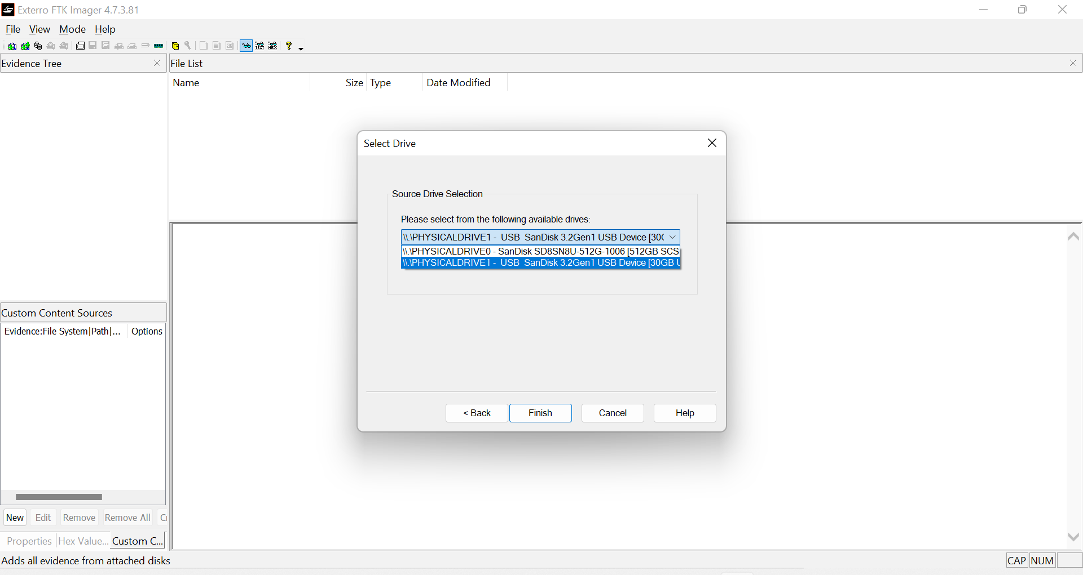

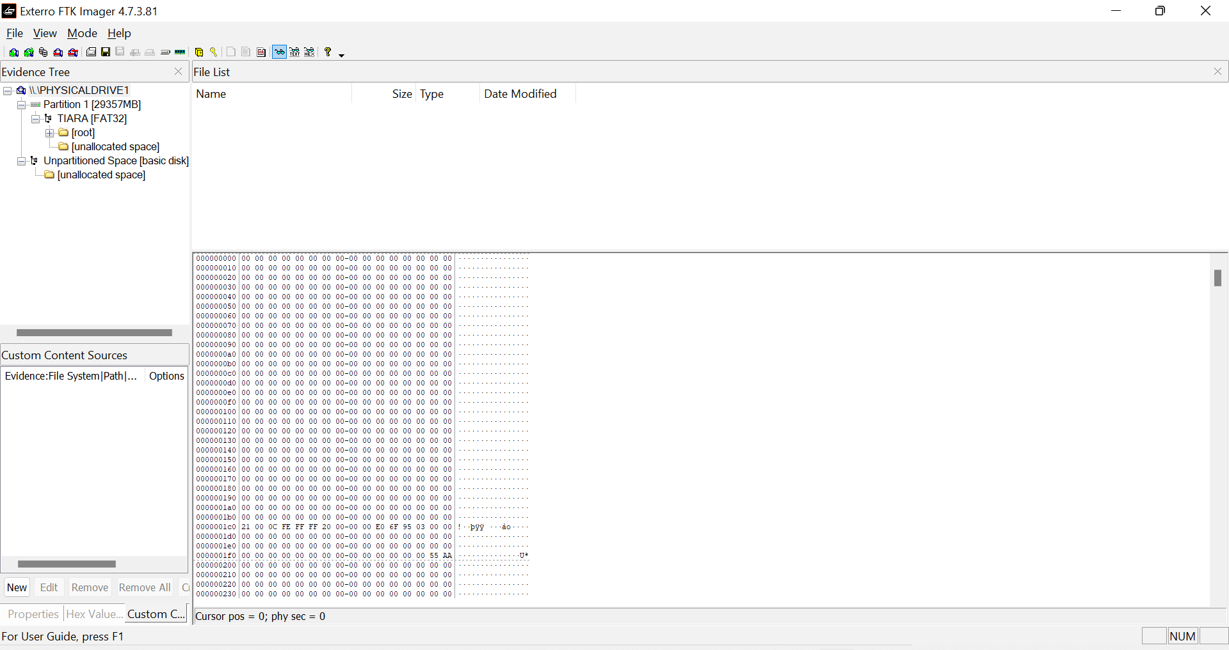

**Step 3:-** Create the Disk Image.

File - Create Disk Image - Physical drive - Next - Select source drive - Select the attached drive in the drop-down menu - Finish

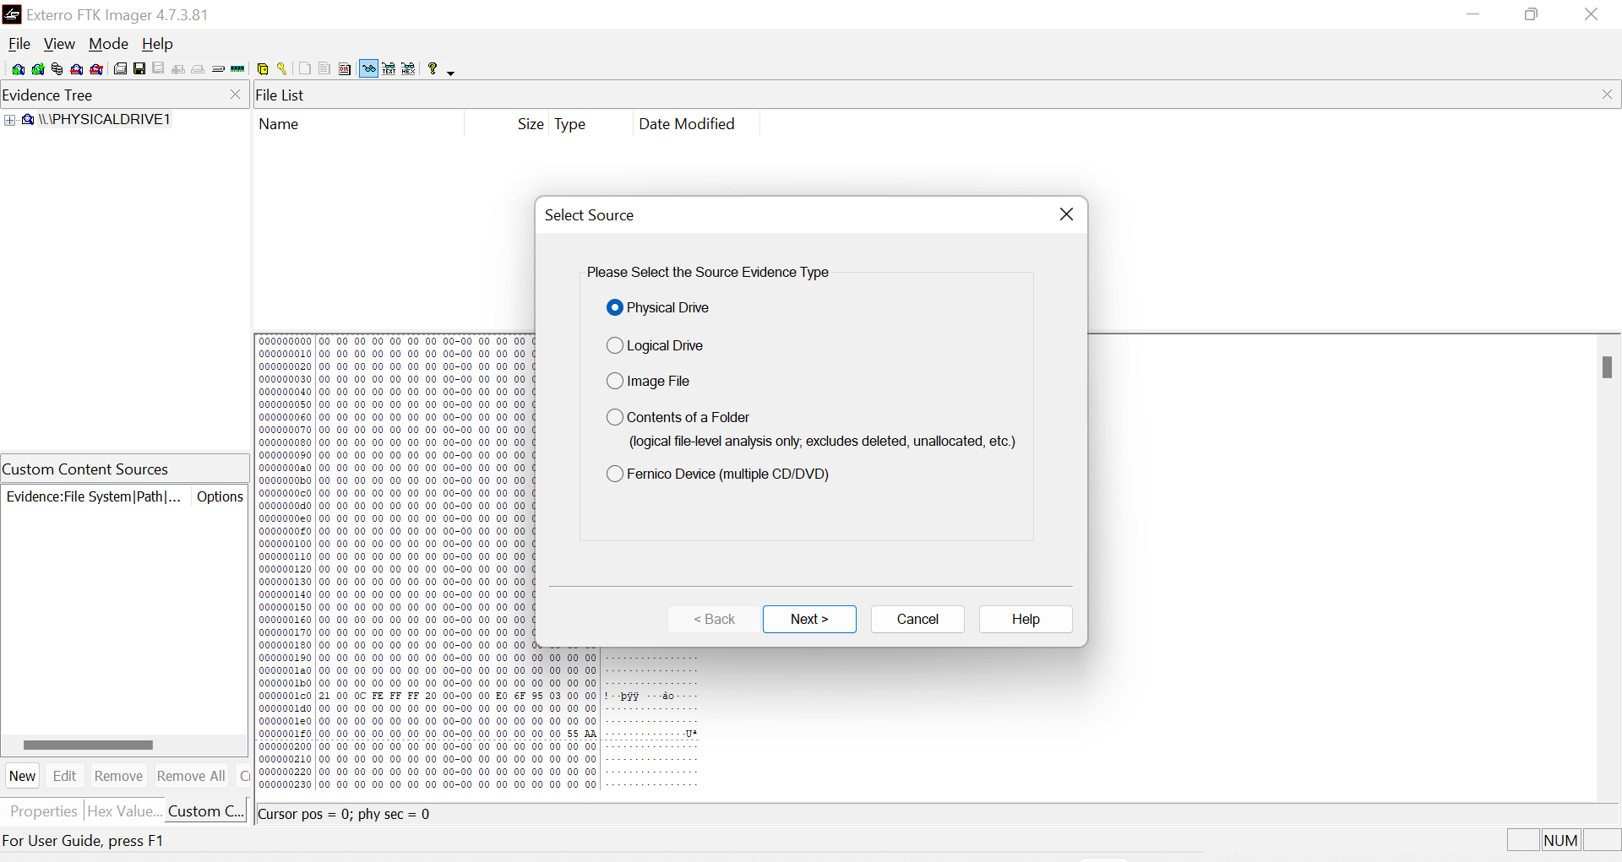

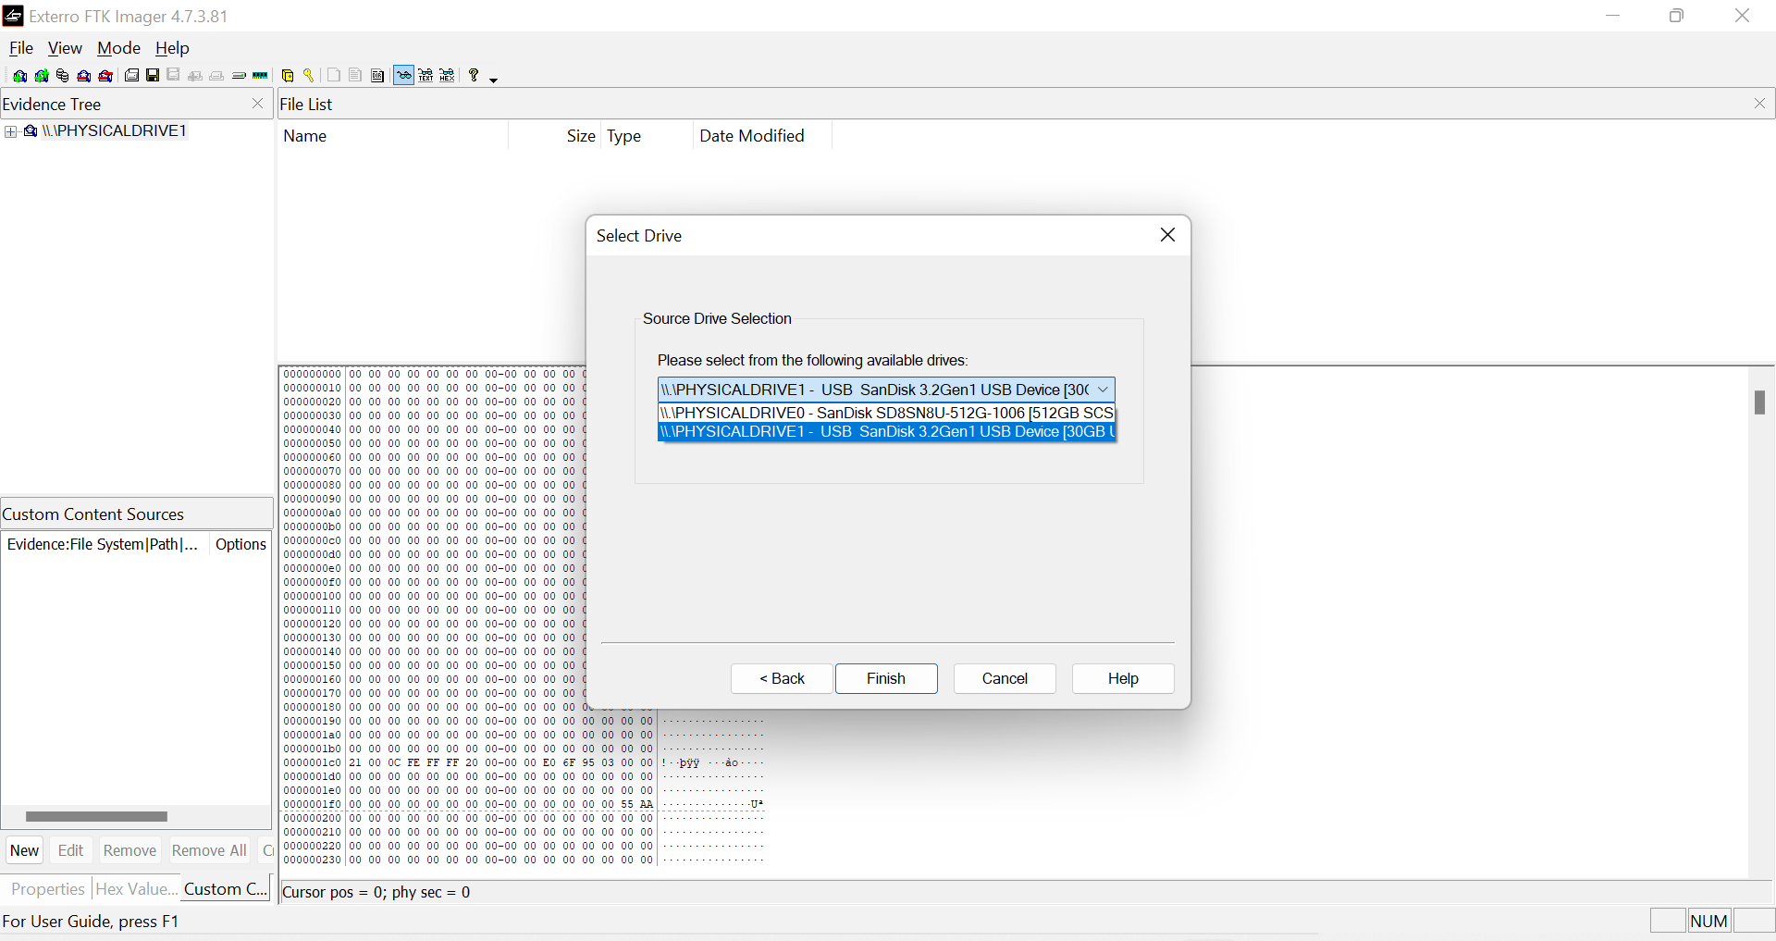

Step 4:- Create and add image - Add - Select image type - Select the destination image type - E01 - Next - Enter evidence item information - Next - Select image destination folder - Image destination folder - browse - DATA ACQUISITION (FTK IMAGER) - OK - Image file name (Case 000101) - Select image fragment size = 0 - Select 6 for compression

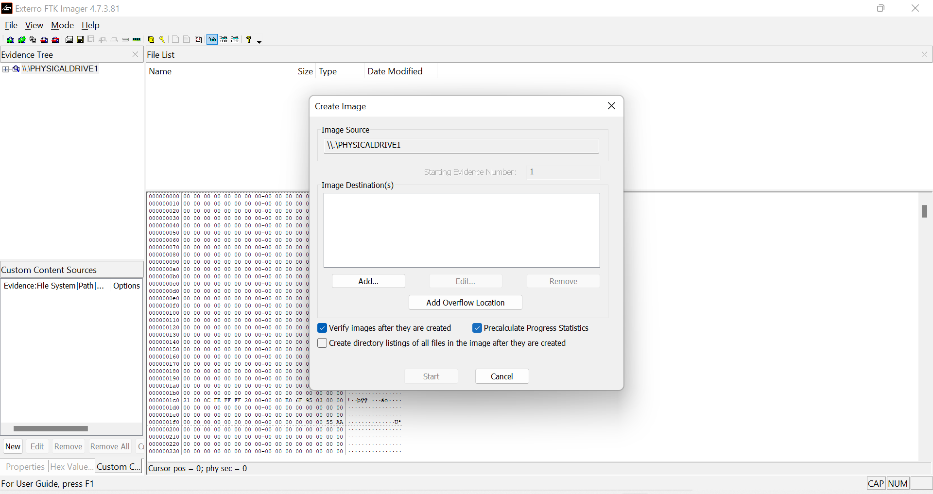

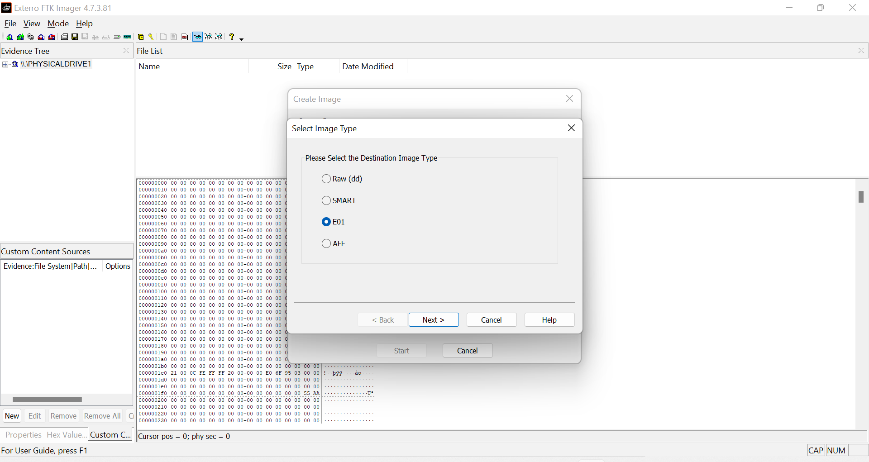

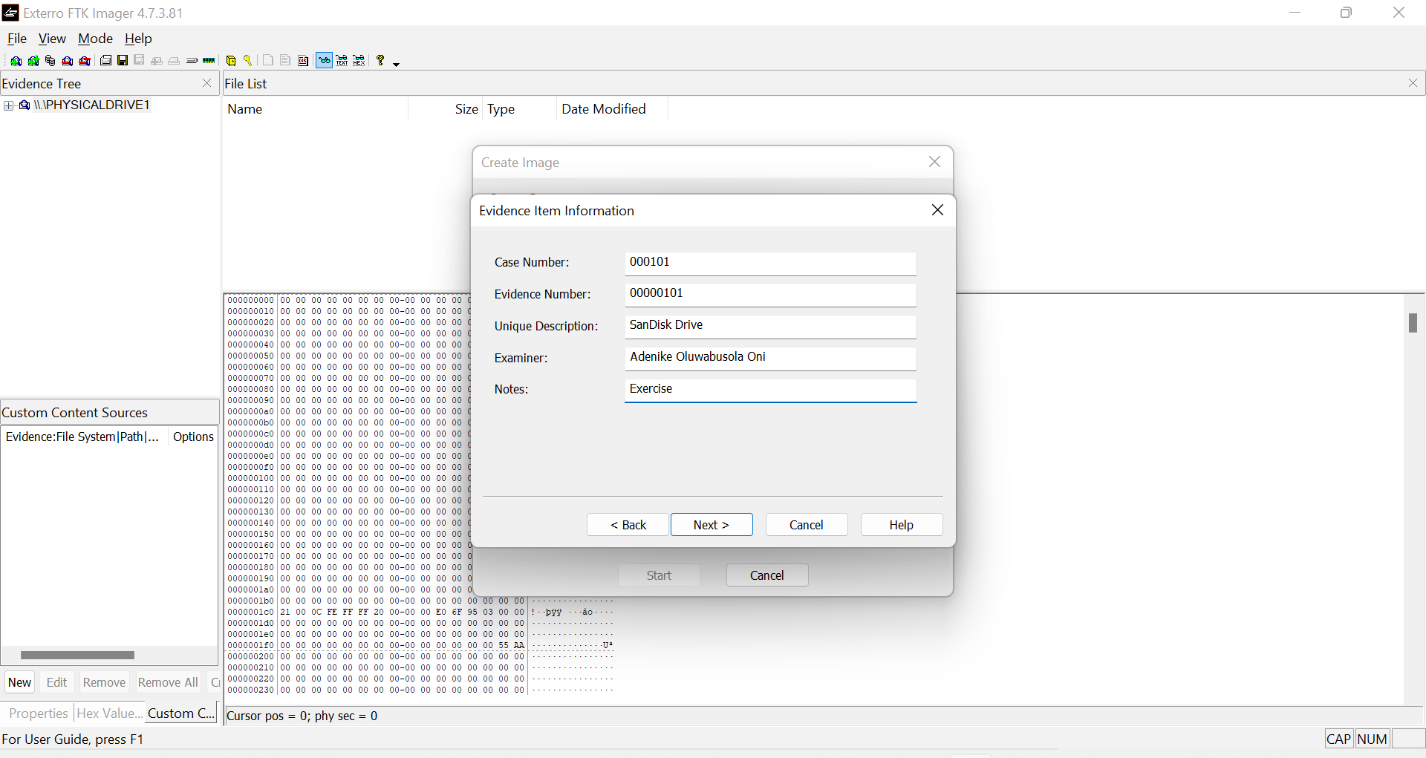

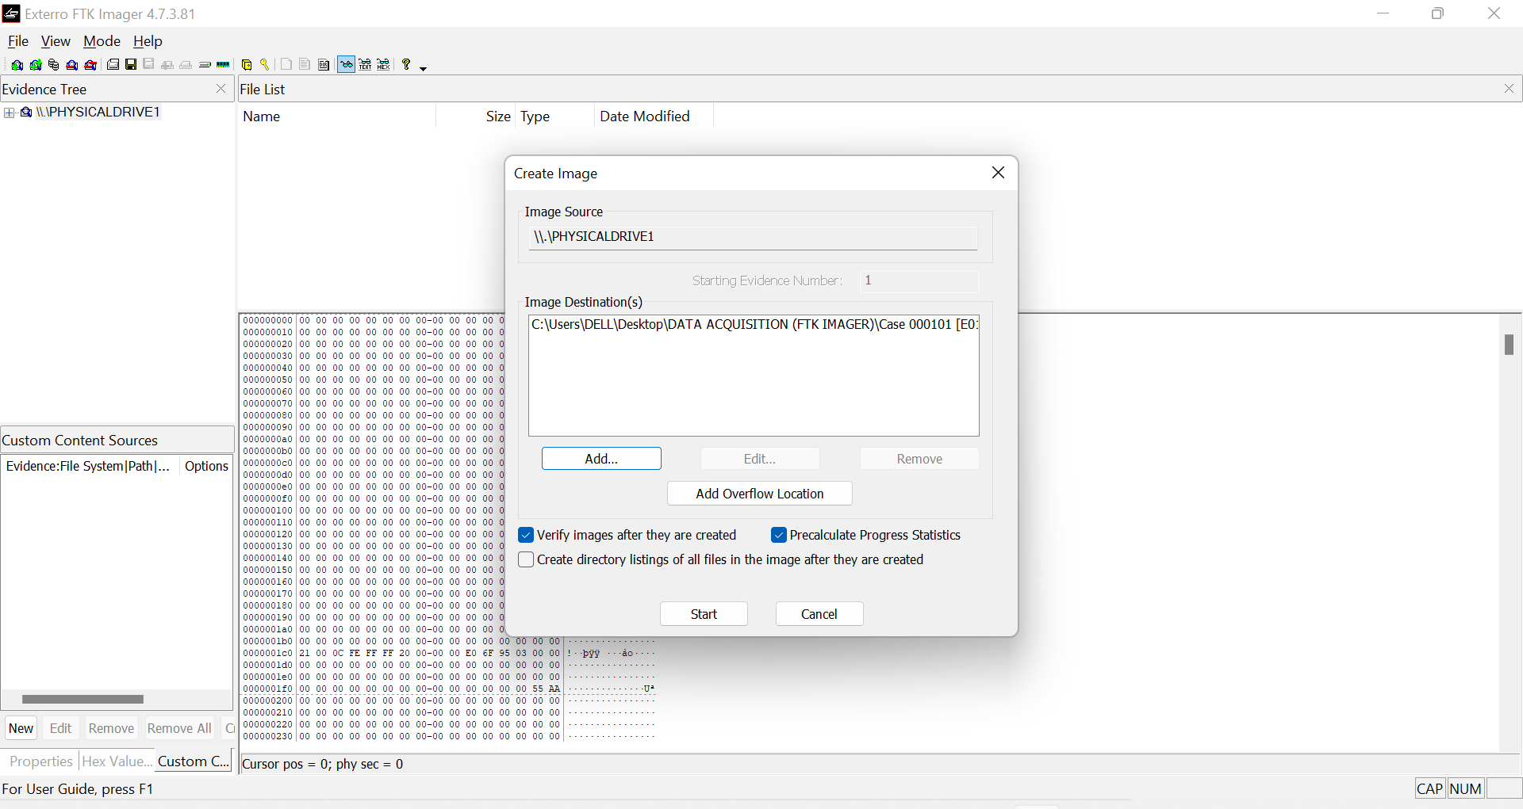

Creating Image

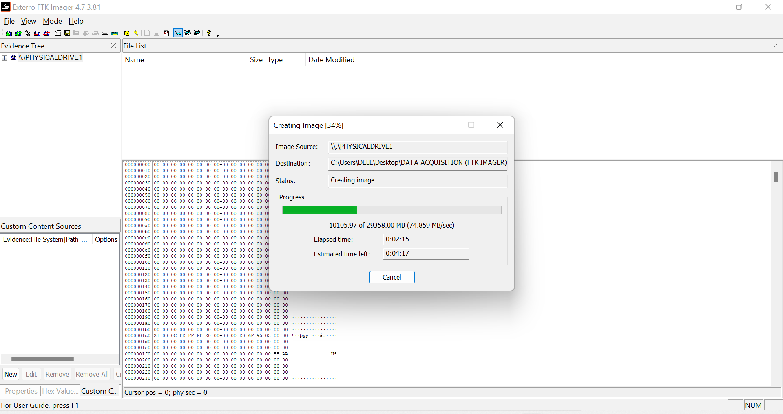

Verifying Image

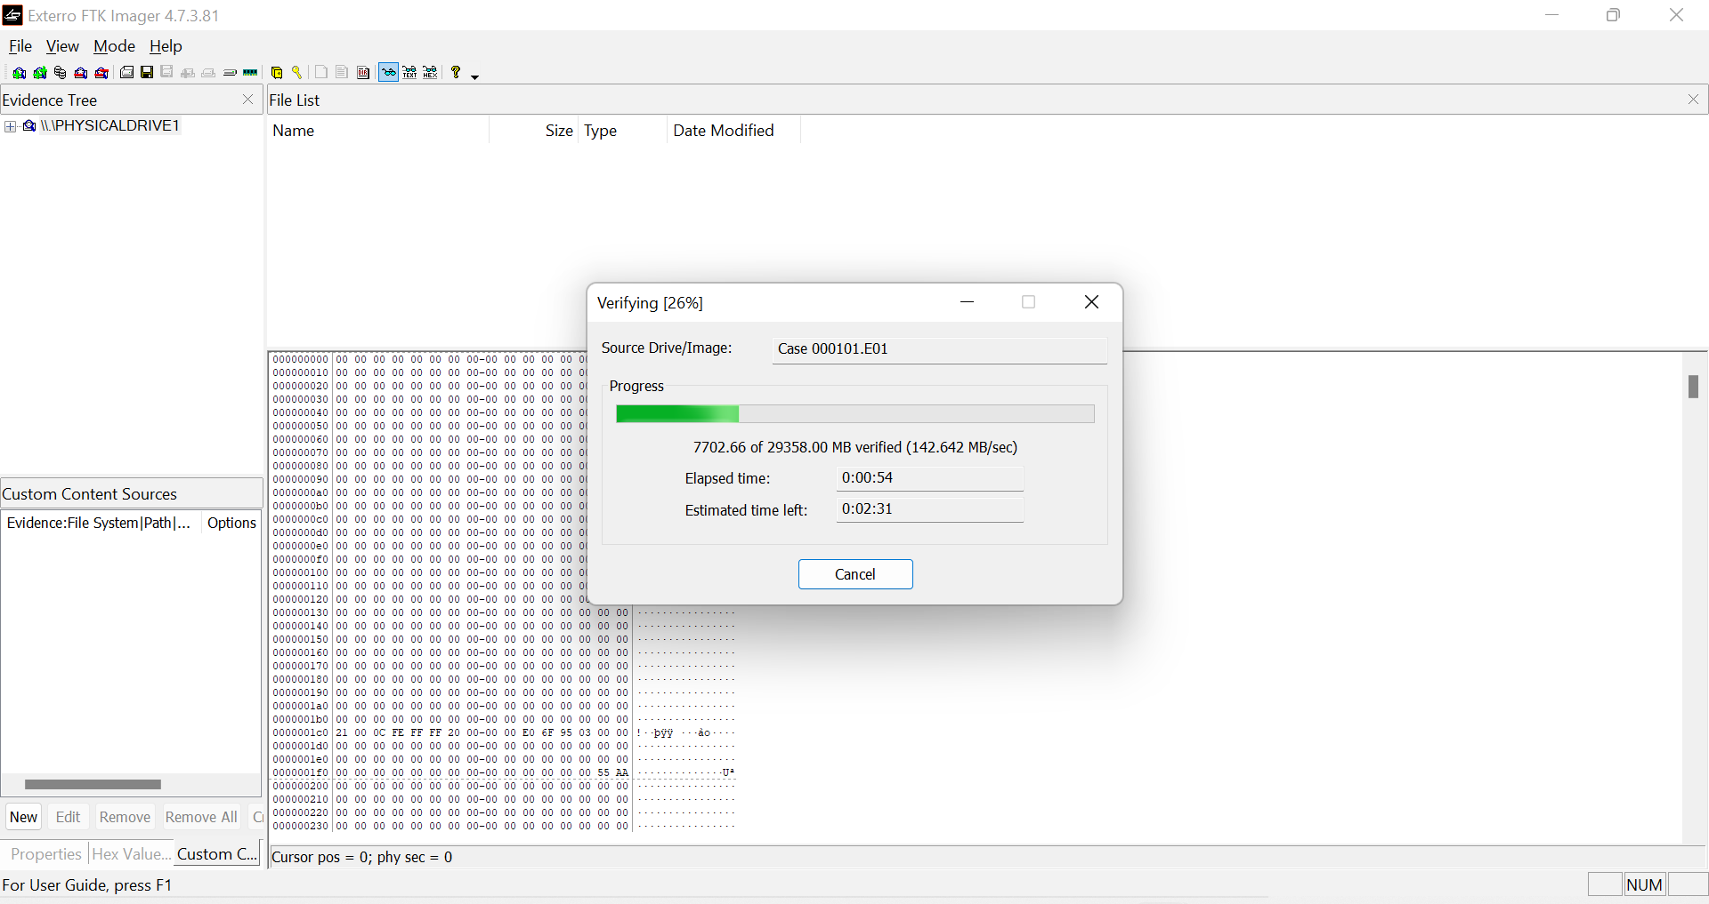

Image created

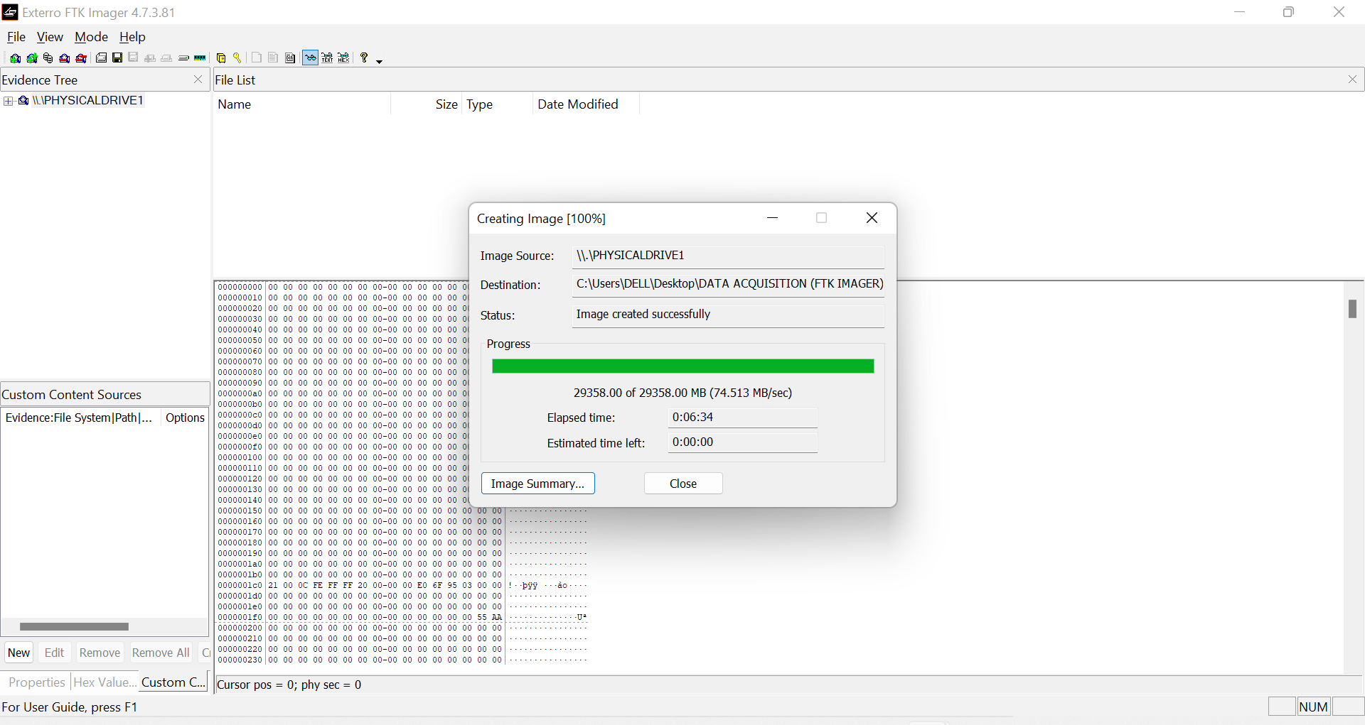

**Drive/Image results**

## 

**Image file folder**

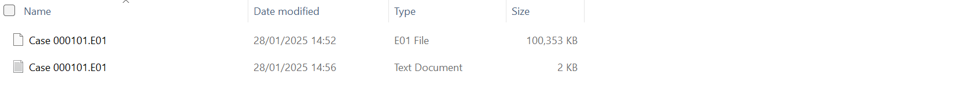

**Text file content**

